|  |  |  |
| --- | --- | --- |
| Name = Awais Usman | Class ID=110804 | Student ID=65454 |
| Assignment= 02 | Date =10/01/2023 | Mentor =Sir Ramzan |

introduction to information and communication technology

**Home page html::**

<!DOCTYPE html>

<html lang="en">

<head>

<title>Home Page</title>

<link href="cz.css" rel="stylesheet">

<link rel="stylesheet" href="https://cdnjs.cloudflare.com/ajax/libs/font-awesome/4.7.0/css/font-awesome.min.css">

<body>

<div class="logo">

<img src="2.png" style="margin-top: 20px; margin-left: 100px;" width="200px">

</div>

<div>

<nav>

<ul>

<li><a href="cz.html">HOME</a></li>

<li><a href="#">PRODUCTS

<i class="fa fa-caret-down" aria-hidden="true"></i>

</a>

<ul>

<li><a href="proudut.html">Laptop</a> </li>

<li><a href="proudut.html">Printer</a> </li>

<li><a href="proudut.html">Monitor</a> </li>

</ul>

</li>

<li><a href="about us.html">ABOUT US</a></li>

<li><a href="service.html">SERVICES</a></li>

<li><a href="contact us.html">CONTACT US</a></li>

</ul>

</nav>

</div>

<div class="fea">

<h4>NEW ARRIVALS</h4>

</div>

<div class="gd">

<div class="box">

<div class="new">New

<img src="3.png" style="padding: 20px;" width="190px" height="190px">

</div>

<h3 class="te">Razer BlackWidow V3<br> Mechanical Gaming Keyboard...</h3>

<p>The name that started it all returns to reassert its dominance. </p>

<ul>

<li>Razer™ Green Mechanical Switches</li>

<li>Transparent switch housing</li>

<li>Doubleshot ABS keycaps</li>

<li>Aluminum Construction</li>

</ul>

<div class="item">

<h1 class="price">RS 22,000</h1>

<input type="button" class="button" value="View Detail">

</div>

</div>

<div class="box1">

<div class="new">New

<img src="4.png" style="padding: 20px;" width="190px" height="190px">

</div>

<h3 class="te">Razer Kiyo Broadcasting Camera<br> with Illumination...</h3>

<p>With the Razer Kiyo, your fans or friends are always just one click away </p>

<ul>

<li>Full Camera Controls</li>

<li>Ring Light. Camera. Action.</li>

<li>Sharper and Smoother</li>

<li>Sharper and smoother</li>

</ul>

<div class="item">

<h1 class="price">RS 19,200</h1>

<input type="button" class="button" value="View Detail">

</div>

</div>

<div class="box1">

<div class="new">New

<img src="5.png" style="padding: 20px;" width="190px" height="190px">

</div>

<h3 class="te">Razer Nommo Chroma - 2.0 PC<br> Gaming Speakers..</h3>

<p>Powerful audio can completely immerse you in your experience. </p>

<ul>

<li>Custom Woven Glass Fiber 3-Inch</li>

<li>Rear-Facing Bass Ports</li>

<li>Powered by Razer Chroma™</li>

<li>Bass Knob with Automatic Gain Control</li>

</ul>

<div class="item">

<h1 class="price">RS 34,200</h1>

<input type="button" class="button" value="View Detail">

</div>

</div>

<div class="box1">

<div class="new">New

<img src="6.png" style="padding: 20px;" width="190px" height="190px">

</div>

<h3 class="te">Razer Viper Ultimate with<br> Charging Dock...</h3>

<p>Forget about average and claim the unfair advantage. </p>

<ul>

<li>Razer™ HyperSpeed technology </li>

<li>Razer™ Focus+ Optical Sensor</li>

<li>Razer™ Optical Mouse Switch</li>

<li>5 On-Board Memory Profiles</li>

</ul>

<div class="item">

<h1 class="price">RS 23,500</h1>

<input type="button" class="button" value="View Detail">

</div>

</div>

<div class="box">

<div class="new">New

<img src="7.png" style="padding: 20px;" width="190px" height="190px">

</div>

<h3 class="te">Razer Seiren Mini -<br> Mercury Ultra-compact</h3>

<p>Big sounds can come in small packages </p>

<ul>

<li>Ultra-precise supercardioid</li>

<li>Professional Recording Quality</li>

<li>Ultra-compact build</li>

<li>Clarity made compact</li>

</ul>

<div class="item">

<h1 class="price">RS 15,100</h1>

<input type="button" class="button" value="View Detail">

</div>

</div>

<div class="box1">

<div class="new">New

<img src="8.png" style="padding: 20px;" width="190px" height="190px">

</div>

<h3 class="te">Corsair H55 RGB 120mm Liquid<br> CPU Cooler - CW-9060052-WW</h3>

<p>The CORSAIR H55 RGB all-in-one... </p>

<ul>

<li>Flexible Motherboard Digital </li>

<li>Concentrated Cooling</li>

<li>High-Performance Cold</li>

<li>Clarity made compact</li>

</ul>

<div class="item">

<h1 class="price">RS 17,500</h1>

<input type="button" class="button" value="View Detail">

</div>

</div>

<div class="box1">

<div class="new">New

<img src="10.png" style="padding: 20px;" width="190px" height="190px">

</div>

<h3 class="te">Corsair K55 RGB PRO Gaming Keyboard CH-9226765-NA</h3>

<p>The CORSAIR H55 RGB all-in-one... </p>

<ul>

<li>Flexible Motherboard Digital </li>

<li>Concentrated Cooling</li>

<li>High-Performance Cold</li>

<li>Clarity made compact</li>

</ul>

<div class="item">

<h1 class="price">RS 13,500</h1>

<input type="button" class="button" value="View Detail">

</div>

</div>

<div class="box1">

<div class="new">New

<img src="9.png" style="padding: 20px;" width="190px" height="190px">

</div>

<h3 class="te">Gigabyte X670 AORUS ELITE AX Socket AM5 AMD Ryzen 7000 </h3>

<p>The CORSAIR H55 RGB all-in-one... </p>

<ul>

<li>Flexible Motherboard Digital </li>

<li>Concentrated Cooling</li>

<li>High-Performance Cold</li>

<li>Clarity made compact</li>

</ul>

<div class="item">

<h1 class="price">RS 92,900</h1>

<input type="button" class="button" value="View Detail">

</div>

</div>

<div class="box">

<div class="new">New

<img src="11.png" style="padding: 20px;" width="190px" height="190px">

</div>

<h3 class="te">Corsair iCUE QL120 RGB 120mm PWM Triple Fan </h3>

<p>Give your PC spectacular lighting... </p>

<ul>

<li>Flexible Motherboard Digital </li>

<li>Concentrated Cooling</li>

<li>High-Performance Cold</li>

<li>Clarity made compact</li>

</ul>

<div class="item">

<h1 class="price">RS 23,900</h1>

<input type="button" class="button" value="View Detail">

</div>

</div>

<div class="box1">

<div class="new">New

<img src="12.png" style="padding: 20px;" width="190px" height="190px">

</div>

<h3 class="te">Corsair XTM50 High Performance Thermal Paste Kit </h3>

<p>Give your PC spectacular lighting... </p>

<ul>

<li>Flexible Motherboard Digital </li>

<li>Concentrated Cooling</li>

<li>High-Performance Cold</li>

<li>Clarity made compact</li>

</ul>

<div class="item">

<h1 class="price">RS 2,500</h1>

<input type="button" class="button" value="View Detail">

</div>

</div>

<div class="box1">

<div class="new">New

<img src="13.png" style="padding: 20px;" width="190px" height="190px">

</div>

<h3 class="te">Corsair TM30 Performance Thermal Paste CT-9010001-WW </h3>

<p>Give your PC spectacular lighting... </p>

<ul>

<li>Flexible Motherboard Digital </li>

<li>Concentrated Cooling</li>

<li>High-Performance Cold</li>

<li>Clarity made compact</li>

</ul>

<div class="item">

<h1 class="price">RS 1,450</h1>

<input type="button" class="button" value="View Detail">

</div>

</div>

<div class="box1">

<div class="new">New

<img src="14.png" style="padding: 20px;" width="190px" height="190px">

</div>

<h3 class="te">Logitech C920e Business Webcam HD 1080p Dual Mics 960-001360</h3>

<p>Give your PC spectacular lighting... </p>

<ul>

<li>Flexible Motherboard Digital </li>

<li>Concentrated Cooling</li>

<li>High-Performance Cold</li>

<li>Clarity made compact</li>

</ul>

<div class="item">

<h1 class="price">RS 18,500</h1>

<input type="button" class="button" value="View Detail">

</div>

</div>

</div>

<h2 class="to">Business Hours: Monday Thursday: 11:00 am to 8:00 pm, Friday: 11:00 am to 1:00 pm & 3:00 pm to

8:00 pm, Sunday Closed.

</h2>

<footer class="fott">

<img src="2.png" width="200px" style="margin-left: 73px; margin-top: 50px;">

<h1 class="pa">Welcome to Computer Zone.<br> Online Computer store in Pakistan.<br>

Buy Dell,<br> Lenovo, HP, Acer laptops at the best<br> prices in Pakistan.</h1>

<h1 class="ba">PRODUCTS</h1>

<ul1 class="ul1">

<li><a href="proudut.html">Laptops</a><br></li>

<li><a href="proudut.html">Pinter</a><br></li>

<li><a href="#">Hardware</a><br></li>

<li><a href="#">Network Products</a><br></li>

</ul1>

</h1>

<h1 class="ta">ACCOUNTS</h1>

<ol>

<li><a href="#">Sign Up</a><br></li>

<li><a href="#">My Account</a><br></li>

<li><a href="#">Shopping Cart</a><br></li>

<li><a href="#">Order History </a><br></li>

</ol>

</h1>

<h1 class="a">CORPORATE</h1>

<ol1 class="ol1">

<li><a href="about us.html">About Us</a><br></li>

<li><a href="contact us.html">Contact US</a><br></li>

<li><a href="service.html">FAQs</a><br></li>

<li><a href="#">Policies </a><br></li>

</ol1>

</h1>

<h1 class="aa">CONTACT</h1>

<h1 class="bb">F 103, 103, 1, Block F North Nazimabad Town,<br> Karachi, Karachi City, Sindh 74600</h1>

</h1>

</footer>

<div class="fot">

<img src="20.png" width="270px" style="margin-left: 500px; margin-top: 5px;">

<h1 class="ee">CopyRight 2023. All rights reseved</h1>

<h1 class="w">Powered By Sayad Akbar</h1>

</div>

</body>

</html>

**Home page css:**

.logo{

width: 100%;

height: 90px;

background-color: #063d79;

margin-top: -10px;

}

nav {

background-color: #0b2b4b;

height: 50px;

}

nav ul {

padding: 0;

margin: 0;

list-style: none;

position: relative;

margin-left: 100px;

}

nav ul li {

display:inline-block;

}

nav a {

display:block;

padding:0 10px;

color:#FFF;

font-size:18px;

line-height: 60px;

text-decoration:none;

height: 50px;

}

nav a:hover {

background-color: rgba(0, 0, 0, 0.4);

color: #fff;

}

nav ul ul li {

width:170px;

float:none;

display:list-item;

position: relative;

margin-left: -100px;

background-color: #ffffff;

}

nav ul ul ul li {

position: relative;

top:-60px;

left:170px;

}

nav ul ul li a {

color: rgb(57, 47, 141);

box-shadow: 0 14px 28px rgba(0,0,0,0,0.25), 0 10px 10px rgba(0,0,0,0,0.22);

transition: .4s;

background: #f2f2f2;

}

nav ul ul {

display: none;

position: absolute;

}

nav ul li:hover > ul {

display:inherit;

}

.fea{

width: 84%;

height: 50px;

background-color: rgb(214, 214, 214);

margin-top: 50px;

margin-left: 100px;

}

h4{

padding: 10px;

color: #49494a;

font-family: system-ui, -apple-system, BlinkMacSystemFont, 'Segoe UI', Roboto, Oxygen, Ubuntu, Cantarell, 'Open Sans', 'Helvetica Neue', sans-serif;

font-size: 19px;

}

.box{

width: 250px;

height: 490px;

float: left;

border: 1px solid #eaeaea;

margin-top: 20px;

box-shadow: 0 14px 28px rgba(0,0,0,0,0.25), 0 10px 10px rgba(0,0,0,0,0.22);

transition: .4s;

box-sizing: border-box;

margin-left: 100px;

}

.box:hover{

box-shadow: 0 3px 6px rgba(0,0,0,0.16),0 3px 6px rgba(0,0,0,0.23);

transform: translate(0px, -8px);

}

.te{

text-align: center;

color: #085eb9;

font-family: system-ui, -apple-system, BlinkMacSystemFont, 'Segoe UI', Roboto, Oxygen, Ubuntu, Cantarell, 'Open Sans', 'Helvetica Neue', sans-serif;

margin-top: -20px;

font-size: 15px;

}

p{

text-align: center;

margin-top: -10px;

color: #7f8c8d;

font-size: 12px;

}

ul li{

font-size: 12px;

color: #8c8c8c;

font-family: system-ui, -apple-system, BlinkMacSystemFont, 'Segoe UI', Roboto, Oxygen, Ubuntu, Cantarell, 'Open Sans', 'Helvetica Neue', sans-serif;

}

.item .price {

margin: 0 15px;

padding: 7px 0 0 0;

text-align: center;

border-top: 1px solid #eee;

}

.price {

font-size: 18px;

font-weight: 700;

color: #49494a;

font-family: system-ui, -apple-system, BlinkMacSystemFont, 'Segoe UI', Roboto, Oxygen, Ubuntu, Cantarell, 'Open Sans', 'Helvetica Neue', sans-serif;

}

.button{

cursor: pointer;

font-family: system-ui, -apple-system, BlinkMacSystemFont, 'Segoe UI', Roboto, Oxygen, Ubuntu, Cantarell, 'Open Sans', 'Helvetica Neue', sans-serif;

text-transform: uppercase;

font-size: 14px;

font-weight: 500;

padding: 8px 18px;

border-radius: 3px;

margin-left: 15px;

background: -webkit-linear-gradient(top,#003B64 5%,#022E4C 100%);

color: #ffffff;

border: 5px;

width: 220px;

}

.button:hover{

box-shadow: 0 3px 6px rgba(0,0,0,0.16),0 3px 6px rgba(0,0,0,0.23);

}

.new{

color: #fff;

font-family: Roboto;

font-size: 10px;

padding: 3px 8px;

width: 30px;

height: 20px;

display: inline-block;

margin-bottom: 3px;

text-transform: uppercase;

border-radius: 2px;

background-color: #ff9000;

margin-left: 10px;

margin-top: 10px;

}

.box1{

width: 250px;

height: 490px;

float: left;

border: 1px solid #eaeaea;

margin-top: 20px;

box-shadow: 0 14px 28px rgba(0,0,0,0,0.25), 0 10px 10px rgba(0,0,0,0,0.22);

transition: .4s;

box-sizing: border-box;

margin-left: 40px;

}

.box1:hover{

box-shadow: 0 3px 6px rgba(0,0,0,0.16),0 3px 6px rgba(0,0,0,0.23);

transform: translate(0px, -8px);

}

.to{

text-align: center;

margin-top: 1560px;

font-size: 12px;

color: #b30024

}

.fott{

width: 100%;

height: 220px;

background-color: #0e5d9a;

margin-top: 50px;

}

.pa{

font-size: 12px;

color: #fff

}

.pa{

font-family: system-ui, -apple-system, BlinkMacSystemFont, 'Segoe UI', Roboto, Oxygen, Ubuntu, Cantarell, 'Open Sans', 'Helvetica Neue', sans-serif;

margin-left: 73px;

}

.ba{

font-size: 20px;

color: #ffffff;

margin-left: 350px;

margin-top: -140px;

}

.ul1 li{

list-style-type: none;

padding: 2px;

}

.ul1 a{

color: #ffffff;

text-decoration: none;

display: inline-block;

margin-left: 350px;

font-family: system-ui, -apple-system, BlinkMacSystemFont, 'Segoe UI', Roboto, Oxygen, Ubuntu, Cantarell, 'Open Sans', 'Helvetica Neue', sans-serif;

font-size: 12px;

}

.ul1 a:hover{

color: yellow;

}

.ta{

font-size: 20px;

color: #ffffff;

margin-left: 550px;

margin-top: -125px;

}

ol li{

list-style-type: none;

padding: 2px;

}

ol a{

color: #ffffff;

text-decoration: none;

display: inline-block;

margin-left: 510px;

font-family: system-ui, -apple-system, BlinkMacSystemFont, 'Segoe UI', Roboto, Oxygen, Ubuntu, Cantarell, 'Open Sans', 'Helvetica Neue', sans-serif;

font-size: 12px;

}

ol a:hover{

color: yellow;

}

.a{

font-size: 20px;

color: #ffffff;

margin-left: 740px;

margin-top: -143px;

}

.ol1 li{

list-style-type: none;

padding: 2px;

}

.ol1 a{

color: #ffffff;

text-decoration: none;

display: inline-block;

margin-left: 740px;

font-family: system-ui, -apple-system, BlinkMacSystemFont, 'Segoe UI', Roboto, Oxygen, Ubuntu, Cantarell, 'Open Sans', 'Helvetica Neue', sans-serif;

font-size: 12px;

}

.ol1 a:hover{

color: yellow;

}

.aa{

font-size: 20px;

color: #ffffff;

margin-left: 940px;

margin-top: -125px;

}

.bb{

font-size: 12px;

color: #ffffff;

margin-left: 945px;

margin-top: 10px;

}

.fot{

width: 100%;

height: 60px;

background-color: #14497e;

}

.ee{

font-family: system-ui, -apple-system, BlinkMacSystemFont, 'Segoe UI', Roboto, Oxygen, Ubuntu, Cantarell, 'Open Sans', 'Helvetica Neue', sans-serif;

font-size: 12px;

color: #ffffff;

margin-top: -40px;

margin-left: 120px;

}

.w{

font-family: system-ui, -apple-system, BlinkMacSystemFont, 'Segoe UI', Roboto, Oxygen, Ubuntu, Cantarell, 'Open Sans', 'Helvetica Neue', sans-serif;

font-size: 12px;

color: #ffffff;

margin-top: -20px;

margin-left: 940px;

}

**Home page Output::**

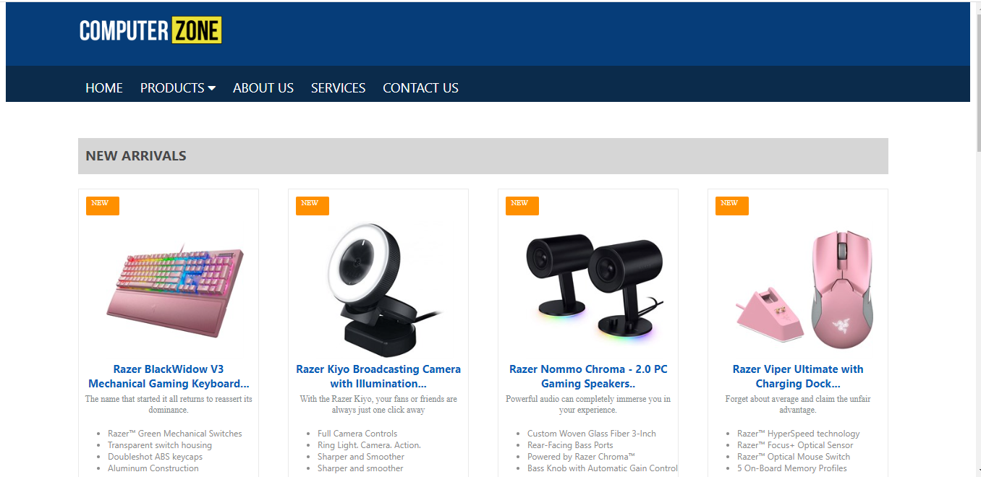

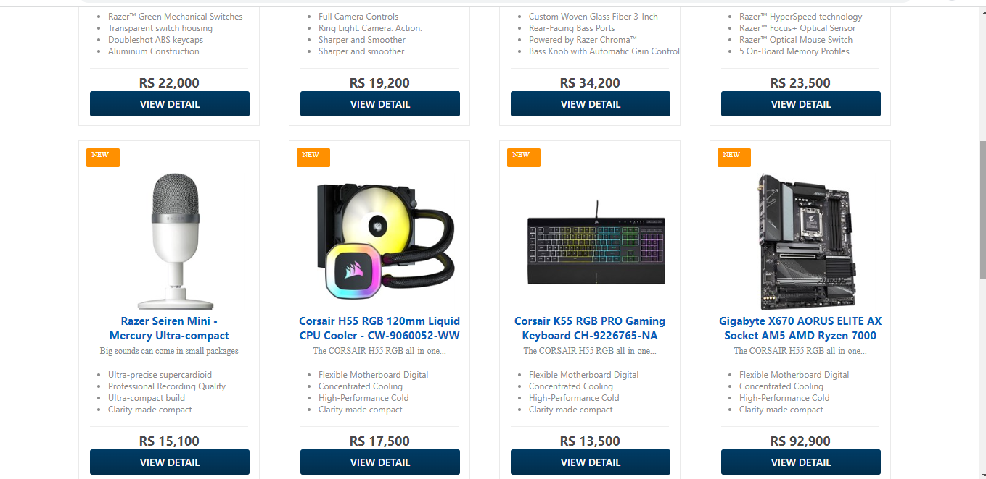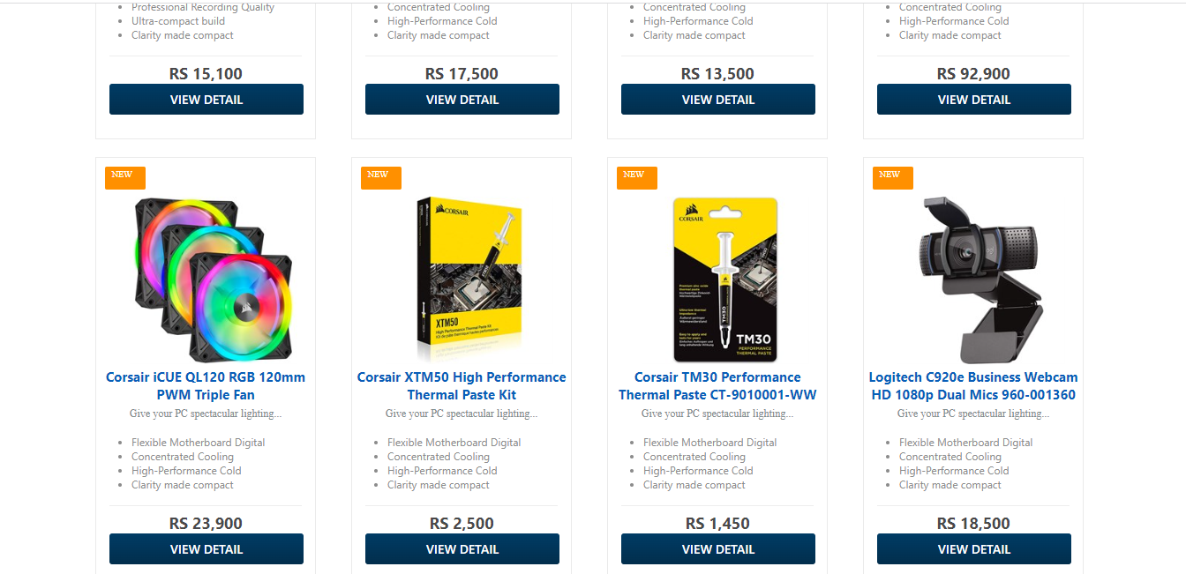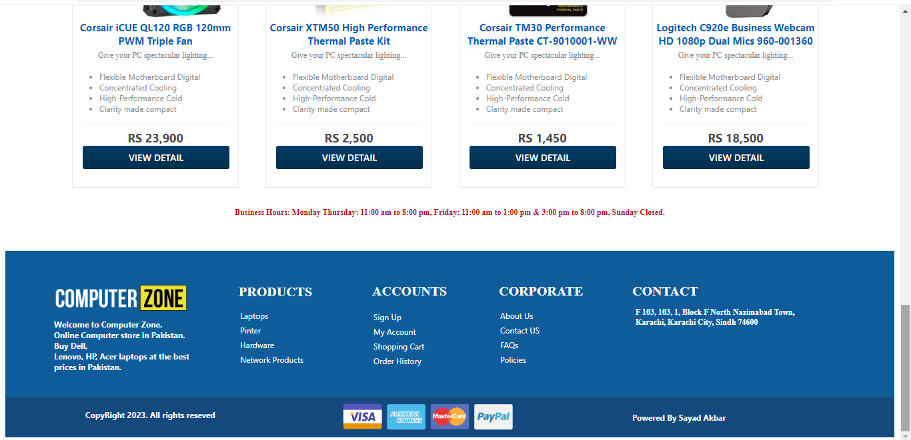

**Product Page html::**

<html>

<head>

<title>Products</title>

<link href="proudut.css" rel="stylesheet">

<link rel="stylesheet" href="https://cdnjs.cloudflare.com/ajax/libs/font-awesome/4.7.0/css/font-awesome.min.css">

</head>

<body>

<div class="logo">

<img src="2.png" style="margin-top: 20px; margin-left: 100px;" width="200px">

</div>

<div>

<nav>

<ul>

<li><a href="cz.html">HOME</a></li>

<li><a href="#">PRODUCTS

<i class="fa fa-caret-down" aria-hidden="true"></i>

</a>

<ul>

<li><a href="proudut.html">Laptop</a> </li>

<li><a href="proudut.html">Printer</a> </li>

<li><a href="proudut.html">Monitor</a> </li>

</ul>

</li>

<li><a href="about us.html">ABOUT US</a></li>

<li><a href="service.html">SERVICES</a></li>

<li><a href="contact us.html">CONTACT US</a></li>

</ul>

</nav>

</div>

<div class="br">

<ul3 class="ul3">

<li><a href="proudut.html">Laptops</a> </li>

<li>/ Products</li>

</ul3>

</div>

<div class="box">

<img src="21.png" style="padding: 20px;" width="190px" height="190px">

<h3 class="te">HP EliteBook 830 G6 Notebook<br> - Intel Core i7-8665U</h3>

<p>Elevate your computing experience with the HP Elitebook 830 . </p>

<ul>

<li>Intel Core i7-8665U Processor</li>

<li>32GB DDR4 2666MHz - 256GB</li>

<li>Intel Graphics - Backlit KB</li>

<li>Windows 10 Pro </li>

</ul>

<div class="item">

<h1 class="price">RS 90,500</h1>

<input type="button" class="button" value="View Detail">

</div>

</div>

<div class="box1">

<img src="22.png" style="padding: 20px;" width="190px" height="190px">

<h3 class="te">HP 14s-DQ5000NIA Laptop <br>- Intel Core i3-1215U</h3>

<p>Stay productive and entertained from anywhere with long-lasting battery life </p>

<ul>

<li>Intel Core i3-1215U Processor</li>

<li>4GB DDR4-3200 - 256GB </li>

<li>Intel UHD Graphics for 12th</li>

<li>14" HD Display</li>

</ul>

<div class="item">

<h1 class="price">RS 98,900</h1>

<input type="button" class="button" value="View Detail">

</div>

</div>

<div class="box1">

<img src="23.png" style="padding: 20px;" width="190px" height="190px">

<h3 class="te">HP 250 G9 Notebook PC - Intel Core i5</h3>

<p>Stay productive and entertained from anywhere with long-lasting battery life </p>

<ul>

<li>Intel Core i3-1215U Processor</li>

<li>4GB DDR4-3200 - 256GB </li>

<li>Intel UHD Graphics for 12th</li>

<li>14" HD Display</li>

</ul>

<div class="item">

<h1 class="price">RS 128,900</h1>

<input type="button" class="button" value="View Detail">

</div>

</div>

<div class="box1">

<img src="24.png" style="padding: 20px;" width="190px" height="190px">

<h3 class="te">HP Pavilion x360 14-EK0013DX <br>2-in-1 Laptop </h3>

<p>Stay productive and entertained from anywhere with long-lasting battery life </p>

<ul>

<li>Intel Core i3-1215U Processor</li>

<li>4GB DDR4-3200 - 256GB </li>

<li>Intel UHD Graphics for 12th</li>

<li>14" HD Display</li>

</ul>

<div class="item">

<h1 class="price">RS 131,900</h1>

<input type="button" class="button" value="View Detail">

</div>

</div>

<div class="brr">

<ul3 class="ul3">

<li><a href="printer.html">Printers</a> </li>

<li>/ Products</li>

</ul3>

</div>

<div class="box">

<img src="31.png" style="padding: 20px;" width="190px" height="190px">

<h3 class="te">HP LaserJet Pro M15a Printer (W2G50A)</h3>

<p>Get fast printing that fits your space and your budget.</p>

<ul>

<li>Print speed black: Normal</li>

<li>Print Resolution Technologies</li>

<li>Duty cycle (monthly, A4) </li>

<li>Processor speed 500 MHz</li>

</ul>

<div class="item">

<h1 class="price">RS 38,500</h1>

<input type="button" class="button" value="View Detail">

</div>

</div>

<div class="box1">

<img src="32.png" style="padding: 20px;" width="190px" height="190px">

<h3 class="te">HP Laser 107a Printer<br> 4ZB77A</h3>

<p>Get the quality you trust and sharp black text with this affordable printer.</p>

<ul>

<li>Print speed black: Normal</li>

<li>Print Resolution Technologies</li>

<li>Duty cycle (monthly, A4) </li>

<li>Processor speed 500 MHz</li>

</ul>

<div class="item">

<h1 class="price">RS 40,500</h1>

<input type="button" class="button" value="View Detail">

</div>

</div>

<div class="box1">

<img src="33.png" style="padding: 20px;" width="190px" height="190px">

<h3 class="te">HP 107w Wireless LaserJet Printer<br> 4ZB78A </h3>

<p>Stay productive and entertained from anywhere with long-lasting battery life </p>

<ul>

<li>Print speed black: Normal</li>

<li>Print Resolution Technologies</li>

<li>Duty cycle (monthly, A4) </li>

<li>Processor speed 500 MHz</li>

</ul>

<div class="item">

<h1 class="price">RS 40,900</h1>

<input type="button" class="button" value="View Detail">

</div>

</div>

<div class="box1">

<img src="34.png" style="padding: 20px;" width="190px" height="190px">

<h3 class="te">HP Neverstop Laser MFP 1200a Printer</h3>

<p>Get the quality you trust and sharp black text with this affordable printer. </p>

<ul>

<li>Print speed black: Normal</li>

<li>Print Resolution Technologies</li>

<li>Duty cycle (monthly, A4) </li>

<li>Processor speed 500 MHz</li>

</ul>

<div class="item">

<h1 class="price">RS 44,500</h1>

<input type="button" class="button" value="View Detail">

</div>

</div>

<div class="brrr">

<ul3 class="ul3">

<li><a href="proudut.html">Monitors</a> </li>

<li>/ Products</li>

</ul3>

</div>

<div class="box">

<img src="41.png" style="padding: 20px;" width="190px" height="190px">

<h3 class="te">Samsung LF24T350FHMXZN 24" LED Monitor</h3>

<p>Minimalist design, maximum concentration</p>

<ul>

<li>Borderless Design, AMD FreeSync</li>

<li>See It from Any Angle</li>

<li>1,920 x 1,080 | Response Time</li>

<li>Superior eye care.</li>

</ul>

<div class="item">

<h1 class="price">RS 47,000</h1>

<input type="button" class="button" value="View Detail">

</div>

</div>

<div class="box1">

<img src="42.png" style="padding: 20px;" width="190px" height="190px">

<h3 class="te">Samsung C24F390FHM 24" Curved Monitor</h3>

<p>Minimalist design, maximum concentration</p>

<ul>

<li>Borderless Design, AMD FreeSync</li>

<li>See It from Any Angle</li>

<li>1,920 x 1,080 | Response Time</li>

<li>Superior eye care.</li>

</ul>

<div class="item">

<h1 class="price">RS 47,900</h1>

<input type="button" class="button" value="View Detail">

</div>

</div>

<div class="box1">

<img src="43.png" style="padding: 20px;" width="190px" height="190px">

<h3 class="te">AOC 27B2H 27" IPS Monitor - 75Hz - Low Blue Light</h3>

<p>Minimalist design, maximum concentration</p>

<ul>

<li>Borderless Design, AMD FreeSync</li>

<li>See It from Any Angle</li>

<li>1,920 x 1,080 | Response Time</li>

<li>Superior eye care.</li>

</ul>

<div class="item">

<h1 class="price">RS 53,500</h1>

<input type="button" class="button" value="View Detail">

</div>

</div>

<div class="box1">

<img src="44.png" style="padding: 20px;" width="190px" height="190px">

<h3 class="te">HP Neverstop Laser MFP 1200a Printer</h3>

<p>Minimalist design, maximum concentration</p>

<ul>

<li>Borderless Design, AMD FreeSync</li>

<li>See It from Any Angle</li>

<li>1,920 x 1,080 | Response Time</li>

<li>Superior eye care.</li>

</ul>

<div class="item">

<h1 class="price">RS 54,900</h1>

<input type="button" class="button" value="View Detail">

</div>

</div>

<footer class="fott">

<img src="2.png" width="200px" style="margin-left: 73px; margin-top: 50px;">

<h1 class="pa">Welcome to Computer Zone.<br> Online Computer store in Pakistan.<br>

Buy Dell,<br> Lenovo, HP, Acer laptops at the best<br> prices in Pakistan.</h1>

<h1 class="ba">PRODUCTS</h1>

<ul1 class="ul1">

<li><a href="proudut.html">Laptops</a><br></li>

<li><a href="proudut.html">Pinter</a><br></li>

<li><a href="#">Hardware</a><br></li>

<li><a href="#">Network Products</a><br></li>

</ul1>

</h1>

<h1 class="ta">ACCOUNTS</h1>

<ol>

<li><a href="#">Sign Up</a><br></li>

<li><a href="#">My Account</a><br></li>

<li><a href="#">Shopping Cart</a><br></li>

<li><a href="#">Order History </a><br></li>

</ol>

</h1>

<h1 class="a">CORPORATE</h1>

<ol1 class="ol1">

<li><a href="about us.html">About Us</a><br></li>

<li><a href="contact us.html">Contact US</a><br></li>

<li><a href="service.html">FAQs</a><br></li>

<li><a href="#">Policies </a><br></li>

</ol1>

</h1>

<h1 class="aa">CONTACT</h1>

<h1 class="bb">F 103, 103, 1, Block F North Nazimabad Town,<br> Karachi, Karachi City, Sindh 74600</h1>

</h1>

</footer>

<div class="fot">

<img src="20.png" width="270px" style="margin-left: 500px; margin-top: 5px;">

<h1 class="ee">CopyRight 2023. All rights reseved</h1>

<h1 class="w">Powered By Sayad Akbar</h1>

</div>

</body>

</html>

**Product Page CSS::**

.logo{

width: 100%;

height: 90px;

background-color: #063d79;

margin-top: -10px;

}

nav {

background-color: #0b2b4b;

height: 50px;

}

nav ul {

padding: 0;

margin: 0;

list-style: none;

position: relative;

margin-left: 100px;

}

nav ul li {

display:inline-block;

}

nav a {

display:block;

padding:0 10px;

color:#FFF;

font-size:18px;

line-height: 60px;

text-decoration:none;

height: 50px;

}

nav a:hover {

background-color: rgba(0, 0, 0, 0.4);

color: #fff;

}

nav ul ul li {

width:170px;

float:none;

display:list-item;

position: relative;

margin-left: -100px;

background-color: #ffffff;

}

nav ul ul ul li {

position: relative;

top:-60px;

left:170px;

}

nav ul ul li a {

color: rgb(57, 47, 141);

box-shadow: 0 14px 28px rgba(0,0,0,0,0.25), 0 10px 10px rgba(0,0,0,0,0.22);

transition: .4s;

background: #f2f2f2;

}

nav ul ul {

display: none;

position: absolute;

}

nav ul li:hover > ul {

display:inherit;

}

.br{

width: 84%;

height: 50px;

background-color: rgb(214, 214, 214);

margin-top: 20px;

margin-left: 100px;

}

.ul3 li{

list-style-type: none;

display: inline-block;

margin-top: 10px;

margin-left: 10px;

color: #34495e;

}

.ul3 a{

text-decoration: none;

color: #34495e;

}

h1{

font-size: 26px;

font-family: system-ui, -apple-system, BlinkMacSystemFont, 'Segoe UI', Roboto, Oxygen, Ubuntu, Cantarell, 'Open Sans', 'Helvetica Neue', sans-serif;

color: #34495e;

margin-left: 100px;

}

.box{

width: 250px;

height: 490px;

float: left;

border: 1px solid #eaeaea;

margin-top: 20px;

box-shadow: 0 14px 28px rgba(0,0,0,0,0.25), 0 10px 10px rgba(0,0,0,0,0.22);

transition: .4s;

box-sizing: border-box;

margin-left: 100px;

}

.box:hover{

box-shadow: 0 3px 6px rgba(0,0,0,0.16),0 3px 6px rgba(0,0,0,0.23);

transform: translate(0px, -8px);

}

.te{

text-align: center;

color: #085eb9;

font-family: system-ui, -apple-system, BlinkMacSystemFont, 'Segoe UI', Roboto, Oxygen, Ubuntu, Cantarell, 'Open Sans', 'Helvetica Neue', sans-serif;

margin-top: -20px;

font-size: 15px;

}

p{

text-align: center;

margin-top: -10px;

color: #7f8c8d;

font-size: 12px;

}

ul li{

font-size: 12px;

color: #8c8c8c;

font-family: system-ui, -apple-system, BlinkMacSystemFont, 'Segoe UI', Roboto, Oxygen, Ubuntu, Cantarell, 'Open Sans', 'Helvetica Neue', sans-serif;

}

.item .price {

margin: 0 15px;

padding: 7px 0 0 0;

text-align: center;

border-top: 1px solid #eee;

}

.price {

font-size: 18px;

font-weight: 700;

color: #49494a;

font-family: system-ui, -apple-system, BlinkMacSystemFont, 'Segoe UI', Roboto, Oxygen, Ubuntu, Cantarell, 'Open Sans', 'Helvetica Neue', sans-serif;

}

.button{

cursor: pointer;

font-family: system-ui, -apple-system, BlinkMacSystemFont, 'Segoe UI', Roboto, Oxygen, Ubuntu, Cantarell, 'Open Sans', 'Helvetica Neue', sans-serif;

text-transform: uppercase;

font-size: 14px;

font-weight: 500;

padding: 8px 18px;

border-radius: 3px;

margin-left: 15px;

background: -webkit-linear-gradient(top,#003B64 5%,#022E4C 100%);

color: #ffffff;

border: 5px;

width: 220px;

}

.button:hover{

box-shadow: 0 3px 6px rgba(0,0,0,0.16),0 3px 6px rgba(0,0,0,0.23);

}

.box1{

width: 250px;

height: 490px;

float: left;

border: 1px solid #eaeaea;

margin-top: 20px;

box-shadow: 0 14px 28px rgba(0,0,0,0,0.25), 0 10px 10px rgba(0,0,0,0,0.22);

transition: .4s;

box-sizing: border-box;

margin-left: 40px;

}

.box1:hover{

box-shadow: 0 3px 6px rgba(0,0,0,0.16),0 3px 6px rgba(0,0,0,0.23);

transform: translate(0px, -8px);

}

.brr{

width: 84%;

height: 50px;

background-color: rgb(214, 214, 214);

margin-left: 100px;

margin-top: 550px;

}

.brrr{

width: 84%;

height: 50px;

background-color: rgb(214, 214, 214);

margin-left: 100px;

margin-top: 550px;

}

.fott{

width: 100%;

height: 220px;

background-color: #0e5d9a;

margin-top: 600px;

}

.pa{

font-size: 12px;

color: #fff

}

.pa{

font-family: system-ui, -apple-system, BlinkMacSystemFont, 'Segoe UI', Roboto, Oxygen, Ubuntu, Cantarell, 'Open Sans', 'Helvetica Neue', sans-serif;

margin-left: 73px;

}

.ba{

font-size: 20px;

color: #ffffff;

margin-left: 350px;

margin-top: -140px;

}

.ul1 li{

list-style-type: none;

padding: 2px;

}

.ul1 a{

color: #ffffff;

text-decoration: none;

display: inline-block;

margin-left: 350px;

font-family: system-ui, -apple-system, BlinkMacSystemFont, 'Segoe UI', Roboto, Oxygen, Ubuntu, Cantarell, 'Open Sans', 'Helvetica Neue', sans-serif;

font-size: 12px;

}

.ul1 a:hover{

color: yellow;

}

.ta{

font-size: 20px;

color: #ffffff;

margin-left: 550px;

margin-top: -125px;

}

ol li{

list-style-type: none;

padding: 2px;

}

ol a{

color: #ffffff;

text-decoration: none;

display: inline-block;

margin-left: 510px;

font-family: system-ui, -apple-system, BlinkMacSystemFont, 'Segoe UI', Roboto, Oxygen, Ubuntu, Cantarell, 'Open Sans', 'Helvetica Neue', sans-serif;

font-size: 12px;

}

ol a:hover{

color: yellow;

}

.a{

font-size: 20px;

color: #ffffff;

margin-left: 740px;

margin-top: -143px;

}

.ol1 li{

list-style-type: none;

padding: 2px;

}

.ol1 a{

color: #ffffff;

text-decoration: none;

display: inline-block;

margin-left: 740px;

font-family: system-ui, -apple-system, BlinkMacSystemFont, 'Segoe UI', Roboto, Oxygen, Ubuntu, Cantarell, 'Open Sans', 'Helvetica Neue', sans-serif;

font-size: 12px;

}

.ol1 a:hover{

color: yellow;

}

.aa{

font-size: 20px;

color: #ffffff;

margin-left: 940px;

margin-top: -125px;

}

.bb{

font-size: 12px;

color: #ffffff;

margin-left: 945px;

margin-top: 10px;

}

.fot{

width: 100%;

height: 60px;

background-color: #14497e;

}

.ee{

font-family: system-ui, -apple-system, BlinkMacSystemFont, 'Segoe UI', Roboto, Oxygen, Ubuntu, Cantarell, 'Open Sans', 'Helvetica Neue', sans-serif;

font-size: 12px;

color: #ffffff;

margin-top: -40px;

margin-left: 120px;

}

.w{

font-family: system-ui, -apple-system, BlinkMacSystemFont, 'Segoe UI', Roboto, Oxygen, Ubuntu, Cantarell, 'Open Sans', 'Helvetica Neue', sans-serif;

font-size: 12px;

color: #ffffff;

margin-top: -20px;

margin-left: 940px;

}

**Product page output::**

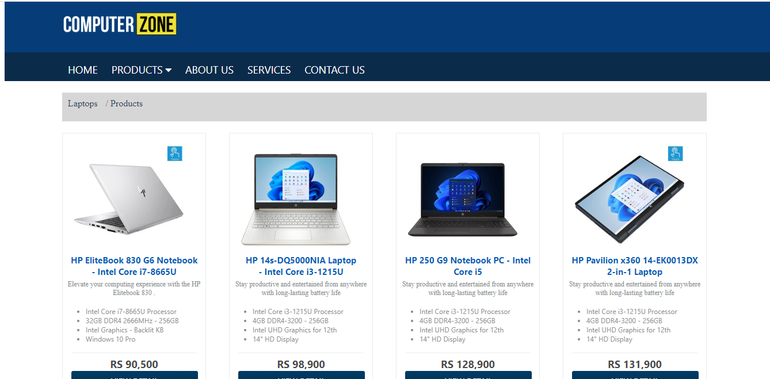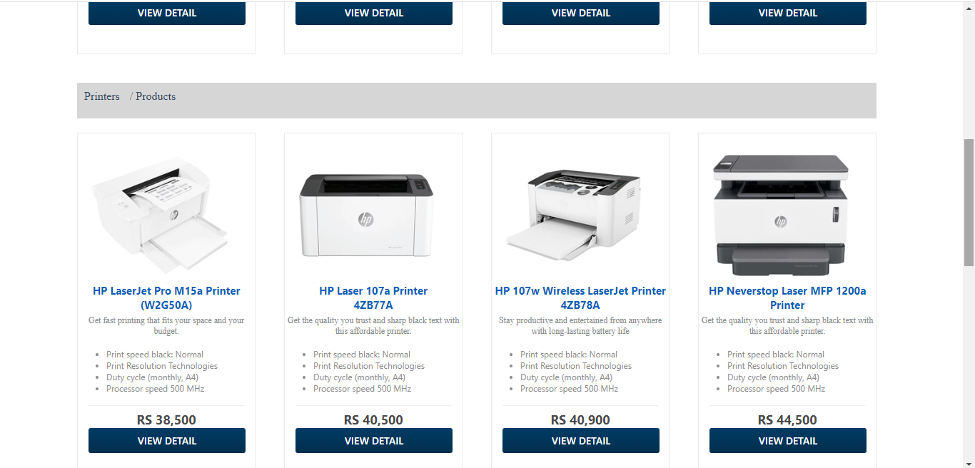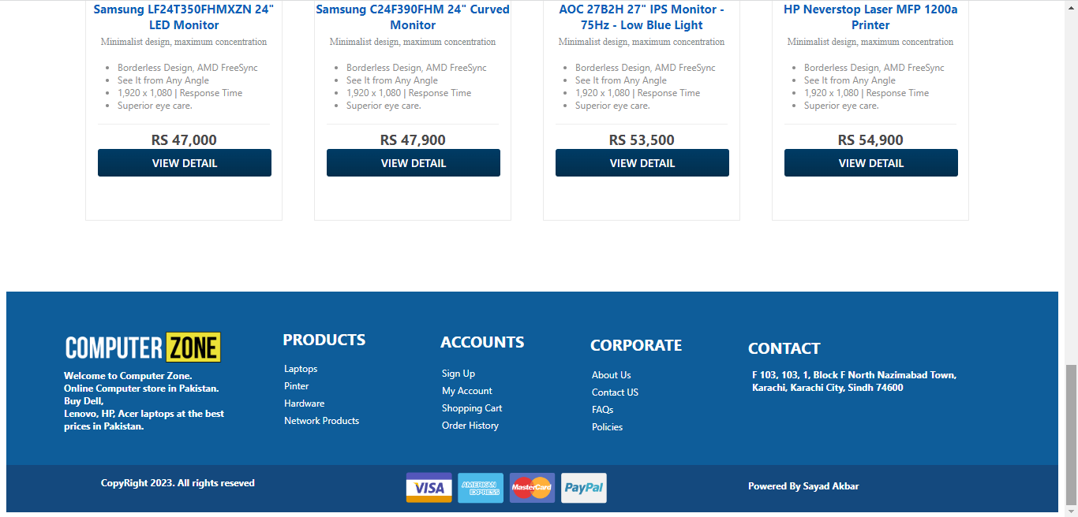

**About us page html::**

<html>

<head>

<title>About Us</title>

<link href="about us.css" rel="stylesheet">

<link rel="stylesheet" href="https://cdnjs.cloudflare.com/ajax/libs/font-awesome/4.7.0/css/font-awesome.min.css">

</head>

<body>

<div class="logo">

<img src="2.png" style="margin-top: 20px; margin-left: 100px;" width="200px">

</div>

<div>

<nav>

<ul>

<li><a href="cz.html">HOME</a></li>

<li><a href="#">PRODUCTS

<i class="fa fa-caret-down" aria-hidden="true"></i>

</a>

<ul>

<li><a href="proudut.html">Laptop</a> </li>

<li><a href="proudut.html">Printer</a> </li>

<li><a href="proudut.html">Monitor</a> </li>

</ul>

</li>

<li><a href="about us.html">ABOUT US</a></li>

<li><a href="service.html">SERVICES</a></li>

<li><a href="contact us.html">CONTACT US</a></li>

</ul>

</nav>

</div>

<div class="br">

<ul3 class="ul3">

<li><a href="cz.html">Home</a> </li>

<li>/ About Us</li>

</ul3>

</div>

<h1>About Us</h1>

<p>Over the period of the last 11 years, YOU have taken Computer Zone from a simple business idea to a revolution in

the heart of Pakistan’s Information Technology market. The<br>

idea behind the development of Computer Zone was never about creating a retailer with good prices; but to give

birth to a place where people could be served as a part of the<br>

family. Where they could actually feel the touch of Information Technology’s application in the way they are

dealt with. The world has moved to the next generation of business<br>

relationships; and we are proud to be the first in Pakistan’s Information Technology market to accept that “Yes,

YOU are important!” With around 1,000% growth rate, we are<br>

proud and extremely happy to quote that Computer Zone has a family of more then a million online family members

and more than 200,000 (and growing) customer’s offline; in<br>

comparison to a total of 10 customers 11 years ago. The world is changing and Computer Zone happily accepts that

the customers of today are more tech savvy and demand<br>

value for their money. We believe that change is the only thing constant and in order to deliver to you the

value you deserve, we are always in the process of evolving to the next<br>

best level.</p>

<p>The success of Computer Zone is not a magical coincidence but a result of experienced professionals listening to

and implementing every suggestion that YOU gifted us with<br>

over the past 11 years. The world has revolutionized and it’s time to move from those close gullied and air

tight markets to a system of automation where you do not need to run<br>

after sales people asking for product specification and quotations. Have a nice sip of coffee, stretch your legs

and go through the updated, complete and vast range of products<br>

awaiting your royal presence by a few clicks. Even if you are not comfortable at dealing with an online market

and need a more personal touch and suggestion to things; come<br>

visit Computer Zone. 11 years ago people didn’t have online markets; and Computer Zone respects your demand for

one to one communication and anxiously awaits your<br>

presence</p>

<p>There might still be a lot of things that you could want to know about Computer Zone. Simply Sign up, feel free,

and don’t be shy. We never tell our customers to hush away<br>

because there are others to deal with or we already met our daily sales quota. So, welcome to Computer Zone; and

don’t you worry because whether you are a corporate client<br>

or an individual customer; we are family now. Welcome to the Information Technology’s Revolution in Pakistan!

</p>

<footer class="fott">

<img src="2.png" width="200px" style="margin-left: 73px; margin-top: 50px;">

<h1 class="pa">Welcome to Computer Zone.<br> Online Computer store in Pakistan.<br>

Buy Dell,<br> Lenovo, HP, Acer laptops at the best<br> prices in Pakistan.</h1>

<h1 class="ba">PRODUCTS</h1>

<ul1 class="ul1">

<li><a href="proudut.html">Laptops</a><br></li>

<li><a href="proudut.html">Pinter</a><br></li>

<li><a href="#">Hardware</a><br></li>

<li><a href="#">Network Products</a><br></li>

</ul1>

</h1>

<h1 class="ta">ACCOUNTS</h1>

<ol>

<li><a href="#">Sign Up</a><br></li>

<li><a href="#">My Account</a><br></li>

<li><a href="#">Shopping Cart</a><br></li>

<li><a href="#">Order History </a><br></li>

</ol>

</h1>

<h1 class="a">CORPORATE</h1>

<ol1 class="ol1">

<li><a href="#">About Us</a><br></li>

<li><a href="contact us.html">Contact Us</a><br></li>

<li><a href="service.html">FAQs</a><br></li>

<li><a href="#">Policies </a><br></li>

</ol1>

</h1>

<h1 class="aa">CONTACT</h1>

<h1 class="bb">F 103, 103, 1, Block F North Nazimabad Town,<br> Karachi, Karachi City, Sindh 74600</h1>

</h1>

</footer>

<div class="fot">

<img src="20.png" width="270px" style="margin-left: 500px; margin-top: 5px;">

<h1 class="ee">CopyRight 2023. All rights reseved</h1>

<h1 class="w">Powered By Sayad Akbar</h1>

</div>

</body>

</html>

**About us css::**

.logo{

width: 100%;

height: 90px;

background-color: #063d79;

margin-top: -10px;

}

nav {

background-color: #0b2b4b;

height: 50px;

}

nav ul {

padding: 0;

margin: 0;

list-style: none;

position: relative;

margin-left: 100px;

}

nav ul li {

display:inline-block;

}

nav a {

display:block;

padding:0 10px;

color:#FFF;

font-size:18px;

line-height: 60px;

text-decoration:none;

height: 50px;

}

nav a:hover {

background-color: rgba(0, 0, 0, 0.4);

color: #fff;

}

nav ul ul li {

width:170px;

float:none;

display:list-item;

position: relative;

margin-left: -100px;

background-color: #ffffff;

}

nav ul ul ul li {

position: relative;

top:-60px;

left:170px;

}

nav ul ul li a {

color: rgb(57, 47, 141);

box-shadow: 0 14px 28px rgba(0,0,0,0,0.25), 0 10px 10px rgba(0,0,0,0,0.22);

transition: .4s;

background: #f2f2f2;

}

nav ul ul {

display: none;

position: absolute;

}

nav ul li:hover > ul {

display:inherit;

}

.br{

width: 84%;

height: 40px;

border: 1px solid #ddd;

margin-top: 20px;

margin-left: 100px;

}

.ul3 li{

list-style-type: none;

display: inline-block;

margin-top: 10px;

margin-left: 10px;

color: #34495e;

}

.ul3 a{

text-decoration: none;

color: #34495e;

}

h1{

font-size: 26px;

font-family: system-ui, -apple-system, BlinkMacSystemFont, 'Segoe UI', Roboto, Oxygen, Ubuntu, Cantarell, 'Open Sans', 'Helvetica Neue', sans-serif;

color: #34495e;

margin-left: 100px;

}

p{

font-size: 14px;

font-family: system-ui, -apple-system, BlinkMacSystemFont, 'Segoe UI', Roboto, Oxygen, Ubuntu, Cantarell, 'Open Sans', 'Helvetica Neue', sans-serif;

margin-left: 100px;

}

.fott{

width: 100%;

height: 220px;

background-color: #0e5d9a;

margin-top: 50px;

}

.pa{

font-size: 12px;

color: #fff

}

.pa{

font-family: system-ui, -apple-system, BlinkMacSystemFont, 'Segoe UI', Roboto, Oxygen, Ubuntu, Cantarell, 'Open Sans', 'Helvetica Neue', sans-serif;

margin-left: 73px;

}

.ba{

font-size: 20px;

color: #ffffff;

margin-left: 350px;

margin-top: -140px;

}

.ul1 li{

list-style-type: none;

padding: 2px;

}

.ul1 a{

color: #ffffff;

text-decoration: none;

display: inline-block;

margin-left: 350px;

font-family: system-ui, -apple-system, BlinkMacSystemFont, 'Segoe UI', Roboto, Oxygen, Ubuntu, Cantarell, 'Open Sans', 'Helvetica Neue', sans-serif;

font-size: 12px;

}

.ul1 a:hover{

color: yellow;

}

.ta{

font-size: 20px;

color: #ffffff;

margin-left: 550px;

margin-top: -125px;

}

ol li{

list-style-type: none;

padding: 2px;

}

ol a{

color: #ffffff;

text-decoration: none;

display: inline-block;

margin-left: 510px;

font-family: system-ui, -apple-system, BlinkMacSystemFont, 'Segoe UI', Roboto, Oxygen, Ubuntu, Cantarell, 'Open Sans', 'Helvetica Neue', sans-serif;

font-size: 12px;

}

ol a:hover{

color: yellow;

}

.a{

font-size: 20px;

color: #ffffff;

margin-left: 740px;

margin-top: -143px;

}

.ol1 li{

list-style-type: none;

padding: 2px;

}

.ol1 a{

color: #ffffff;

text-decoration: none;

display: inline-block;

margin-left: 740px;

font-family: system-ui, -apple-system, BlinkMacSystemFont, 'Segoe UI', Roboto, Oxygen, Ubuntu, Cantarell, 'Open Sans', 'Helvetica Neue', sans-serif;

font-size: 12px;

}

.ol1 a:hover{

color: yellow;

}

.aa{

font-size: 20px;

color: #ffffff;

margin-left: 940px;

margin-top: -125px;

}

.bb{

font-size: 12px;

color: #ffffff;

margin-left: 945px;

margin-top: 10px;

}

.fot{

width: 100%;

height: 60px;

background-color: #14497e;

}

.ee{

font-family: system-ui, -apple-system, BlinkMacSystemFont, 'Segoe UI', Roboto, Oxygen, Ubuntu, Cantarell, 'Open Sans', 'Helvetica Neue', sans-serif;

font-size: 12px;

color: #ffffff;

margin-top: -40px;

margin-left: 120px;

}

.w{

font-family: system-ui, -apple-system, BlinkMacSystemFont, 'Segoe UI', Roboto, Oxygen, Ubuntu, Cantarell, 'Open Sans', 'Helvetica Neue', sans-serif;

font-size: 12px;

color: #ffffff;

margin-top: -20px;

margin-left: 940px;

}

**About us Output::**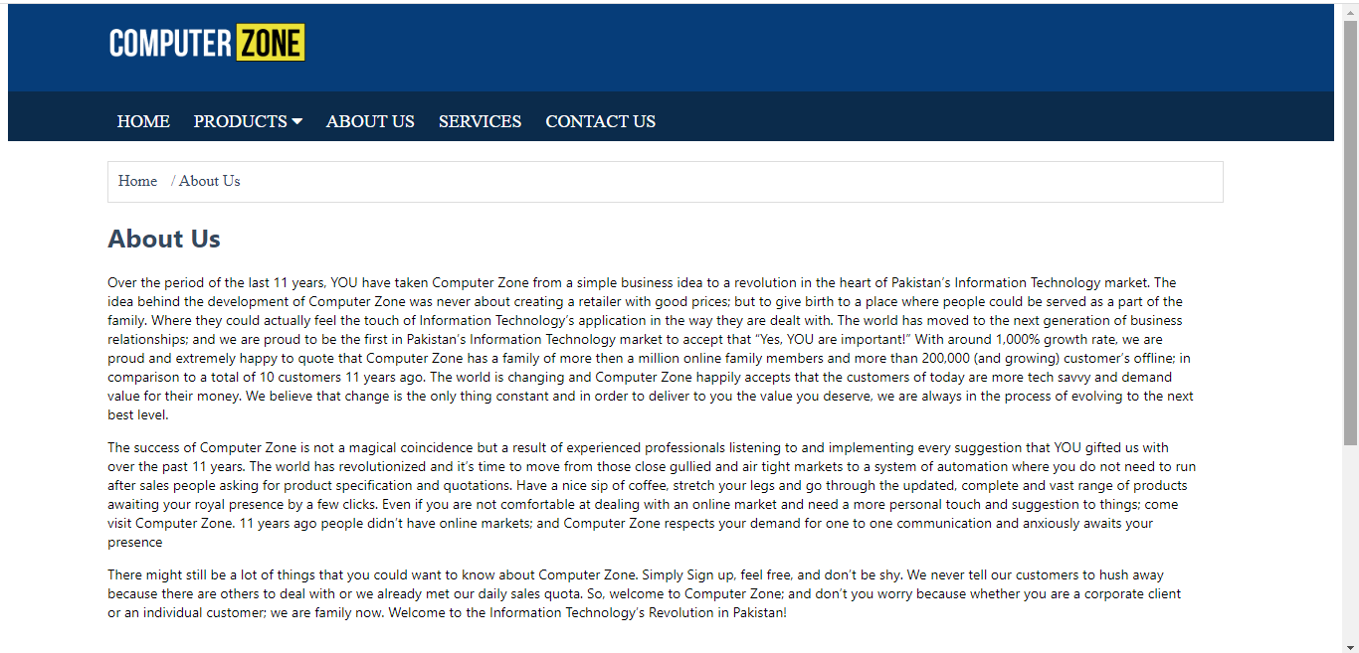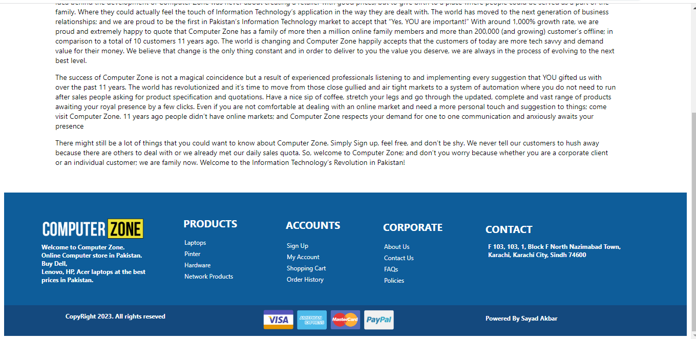

**Contact us page html::**

<!DOCTYPE html>

<html lang="en">

<head>

<title>Contact US</title>

<link href="contact us.css" rel="stylesheet">

<link rel="stylesheet" href="https://cdnjs.cloudflare.com/ajax/libs/font-awesome/4.7.0/css/font-awesome.min.css">

</head>

<body>

<body>

<div class="logo">

<img src="2.png" style="margin-top: 20px; margin-left: 100px;" width="200px">

</div>

<div>

<nav>

<ul>

<li><a href="cz.html">HOME</a></li>

<li><a href="#">PRODUCTS

<i class="fa fa-caret-down" aria-hidden="true"></i>

</a>

<ul>

<li><a href="proudut.html">Laptop</a> </li>

<li><a href="proudut.html">Printer</a> </li>

<li><a href="proudut.html">Monitor</a> </li>

</ul>

</li>

<li><a href="about us.html">ABOUT US</a></li>

<li><a href="service.html">SERVICES</a></li>

<li><a href="contact us.html">CONTACT US</a></li>

</ul>

</nav>

</div>

<div class="br">

<ul3 class="ul3">

<li><a href="cz.html">Home</a> </li>

<li>/ Contact Us</li>

</ul3>

</div>

<div class="main">

<img src="tt.png" width="40px" style="margin-top:10px;">

<h1>Contact Us</h1>

<p>Use the following contact details to contact us or fill up the below contact form. We'll r

espond to your query as soon as possible.</p>

<div class="si">

<h2 class="hh">CONTACT DETAILS</h2>

<div class="l"></div>

<p class="pp">Computer Zone<br><br>

Adress: etc etc etc etc etc<br><br>

Phone: 000000000000<br><br>

Email: abc@gmail.com<br><br>

Website: www.dummycomputerzone.com

</p>

</div>

<div class="fr">

<h2 class="hh">CONTACT DETAILS</h2>

<div class="l">

<p class="h4h">Full Name</p>

<div class="ig">

<img src="st.png" width="5px" height="5px">

</div>

<input type="name" placeholder="Full Name" class="na" size="43px">

<p class="h4p">Company Name</p>

<input type="name" placeholder="Company Name" class="na1" size="43px">

<p class="h4b">Email Address</p>

<div class="ig1">

<img src="st.png" width="5px" height="5px">

</div>

<input type="name" placeholder="Email Address" class="na2" size="43px">

<p class="h4q">Phone / Mobile</p>

<input type="name" placeholder="Phone / Mobile" class="na3" size="43px">

<p class="h4r">Category</p>

<div class="ig2">

<img src="st.png" width="5px" height="5px">

</div>

<select name="Select" class="na4">

<option value="Website">Website</option>

<option value="Products">Products</option>

<option value="Other">Other</option>

<option value="Order">Order</option>

</select>

<p class="h4v">Subject</p>

<input type="name" placeholder="Subject" class="na5">

<p class="h44">Comment</p>

<div class="ig3">

<img src="st.png" width="5px" height="5px">

</div>

<textarea name="" class="na6" cols="95" rows="10"></textarea>

<input type="button" class="button" value="Submit">

</div>

<div class="m">

<img src="m.png" width="1115px" height="300px">

</div>

</div>

</div>

<footer class="fott">

<img src="2.png" width="200px" style="margin-left: 73px; margin-top: 50px;">

<h1 class="pa">Welcome to Computer Zone.<br> Online Computer store in Pakistan.<br>

Buy Dell,<br> Lenovo, HP, Acer laptops at the best<br> prices in Pakistan.</h1>

<h1 class="ba">PRODUCTS</h1>

<ul1 class="ul1">

<li><a href="proudut.html">Laptops</a><br></li>

<li><a href="proudut.html">Pinter</a><br></li>

<li><a href="#">Hardware</a><br></li>

<li><a href="#">Network Products</a><br></li>

</ul1>

</h1>

<h1 class="ta">ACCOUNTS</h1>

<ol>

<li><a href="#">Sign Up</a><br></li>

<li><a href="#">My Account</a><br></li>

<li><a href="#">Shopping Cart</a><br></li>

<li><a href="#">Order History </a><br></li>

</ol>

</h1>

<h1 class="a">CORPORATE</h1>

<ol1 class="ol1">

<li><a href="about us.html">About Us</a><br></li>

<li><a href="contact us.html">Contact Us</a><br></li>

<li><a href="service.html">FAQs</a><br></li>

<li><a href="#">Policies </a><br></li>

</ol1>

</h1>

<h1 class="aa">CONTACT</h1>

<h1 class="bb">F 103, 103, 1, Block F North Nazimabad Town,<br> Karachi, Karachi City, Sindh 74600</h1>

</h1>

</footer>

<div class="fot">

<img src="20.png" width="270px" style="margin-left: 500px; margin-top: 5px;">

<h1 class="ee">CopyRight 2023. All rights reseved</h1>

<h1 class="w">Powered By Sayad Akbar</h1>

</div>

</body>

</html>

**Contact us page css::**

.logo{

width: 100%;

height: 90px;

background-color: #063d79;

margin-top: -10px;

}

nav {

background-color: #0b2b4b;

height: 50px;

}

nav ul {

padding: 0;

margin: 0;

list-style: none;

position: relative;

margin-left: 100px;

}

nav ul li {

display:inline-block;

}

nav a {

display:block;

padding:0 10px;

color:#FFF;

font-size:18px;

line-height: 60px;

text-decoration:none;

height: 50px;

}

nav a:hover {

background-color: rgba(0, 0, 0, 0.4);

color: #fff;

}

nav ul ul li {

width:170px;

float:none;

display:list-item;

position: relative;

margin-left: -100px;

background-color: #ffffff;

}

nav ul ul ul li {

position: relative;

top:-60px;

left:170px;

}

nav ul ul li a {

color: rgb(57, 47, 141);

box-shadow: 0 14px 28px rgba(0,0,0,0,0.25), 0 10px 10px rgba(0,0,0,0,0.22);

transition: .4s;

background: #f2f2f2;

}

nav ul ul {

display: none;

position: absolute;

}

nav ul li:hover > ul {

display:inherit;

}

.br{

width: 84%;

height: 40px;

border: 1px solid #ddd;

margin-top: 20px;

margin-left: 100px;

}

.ul3 li{

list-style-type: none;

display: inline-block;

margin-top: 10px;

margin-left: 10px;

color: #34495e;

}

.ul3 a{

text-decoration: none;

color: #34495e;

}

h1{

font-size: 30px;

font-family: system-ui, -apple-system, BlinkMacSystemFont, 'Segoe UI', Roboto, Oxygen, Ubuntu, Cantarell, 'Open Sans', 'Helvetica Neue', sans-serif;

color: #34495e;

margin-top: -45px;

margin-left: 40px;

}

p{

font-size: 14px;

color: #34495e;

font-family:system-ui, -apple-system, BlinkMacSystemFont, 'Segoe UI', Roboto, Oxygen, Ubuntu, Cantarell, 'Open Sans', 'Helvetica Neue', sans-serif;

}

.main{

width: 84%;

height: 1070px;

border: 1px solid #ffffff;

margin-left: 100px;

}

.si{

width: 300px;

height: 270px;

float: left;

border: 1px solid #cecece;

box-shadow: 0 14px 28px rgba(0,0,0,0,0.25), 0 10px 10px rgba(0,0,0,0,0.22);

transition: .4s;

box-sizing: border-box;

float: left;

}

.hh{

font-size: 14px;

color: #34495e;

font-family:system-ui, -apple-system, BlinkMacSystemFont, 'Segoe UI', Roboto, Oxygen, Ubuntu, Cantarell, 'Open Sans', 'Helvetica Neue', sans-serif;

margin-left: 15px;

}

.l{

margin: 0 15px;

padding: 7px 0 0 0;

text-align: center;

border-top: 1px solid #cecece;

}

.pp{

font-size: 14px;

color: #34495e;

font-family:system-ui, -apple-system, BlinkMacSystemFont, 'Segoe UI', Roboto, Oxygen, Ubuntu, Cantarell, 'Open Sans', 'Helvetica Neue', sans-serif;

margin-left: 15px;

}

.fr{

width: 793px;

height: 640px;

float: left;

border: 1px solid #cecece;

box-shadow: 0 14px 28px rgba(0,0,0,0,0.25), 0 10px 10px rgba(0,0,0,0,0.22);

transition: .4s;

box-sizing: border-box;

margin-left: 26px;

}

.h4h{

font-size: 14px;

color: #34495e;

font-family:system-ui, -apple-system, BlinkMacSystemFont, 'Segoe UI', Roboto, Oxygen, Ubuntu, Cantarell, 'Open Sans', 'Helvetica Neue', sans-serif;

margin-left: -706px;

}

.ig{

margin-left: -635px;

margin-top: -40px;

}

.na{

height: 30px;

margin-left: -430px;

margin-top: 15px;

position: relative;

}

.h4p{

font-size: 14px;

color: #34495e;

font-family:system-ui, -apple-system, BlinkMacSystemFont, 'Segoe UI', Roboto, Oxygen, Ubuntu, Cantarell, 'Open Sans', 'Helvetica Neue', sans-serif;

margin-top: -60px;

margin-left: 90px;

}

.na1{

height: 30px;

margin-left: 330px;

margin-top: -30px;

position: relative;

}

.h4b{

font-size: 14px;

color: #34495e;

font-family:system-ui, -apple-system, BlinkMacSystemFont, 'Segoe UI', Roboto, Oxygen, Ubuntu, Cantarell, 'Open Sans', 'Helvetica Neue', sans-serif;

margin-top: 20px;

margin-left: -680px;

}

.ig1{

margin-left: -580px;

margin-top: -40px;

}

.na2{

height: 30px;

margin-left: -430px;

margin-top: 15px;

position: relative;

}

.h4q{

font-size: 14px;

color: #34495e;

font-family:system-ui, -apple-system, BlinkMacSystemFont, 'Segoe UI', Roboto, Oxygen, Ubuntu, Cantarell, 'Open Sans', 'Helvetica Neue', sans-serif;

margin-top: -60px;

margin-left: 90px;

}

.na3{

height: 30px;

margin-left: 330px;

margin-top: -30px;

position: relative;

}

.h4r{

font-size: 14px;

color: #34495e;

font-family:system-ui, -apple-system, BlinkMacSystemFont, 'Segoe UI', Roboto, Oxygen, Ubuntu, Cantarell, 'Open Sans', 'Helvetica Neue', sans-serif;

margin-top: 20px;

margin-left: -705px;

}

.ig2{

margin-left: -635px;

margin-top: -40px;

}

.na4{

width: 720px;

height: 35px;

margin-left: -45px;

margin-top: 15px;

position: relative;

}

.h4v{

font-size: 14px;

color: #34495e;

font-family:system-ui, -apple-system, BlinkMacSystemFont, 'Segoe UI', Roboto, Oxygen, Ubuntu, Cantarell, 'Open Sans', 'Helvetica Neue', sans-serif;

margin-top: 20px;

margin-left: -710px;

}

.na5{

width: 710px;

height: 35px;

margin-left: -45px;

margin-top: -10px;

position: relative;

}

.h44{

font-size: 14px;

color: #34495e;

font-family:system-ui, -apple-system, BlinkMacSystemFont, 'Segoe UI', Roboto, Oxygen, Ubuntu, Cantarell, 'Open Sans', 'Helvetica Neue', sans-serif;

margin-top: 20px;

margin-left: -701px;

}

.ig3{

margin-left: -635px;

margin-top: -40px;

}

.na6{

margin-left: -45px;

margin-top: 10px;

resize: none;

position: relative;

}

.button{

cursor: pointer;

font-family: system-ui, -apple-system, BlinkMacSystemFont, 'Segoe UI', Roboto, Oxygen, Ubuntu, Cantarell, 'Open Sans', 'Helvetica Neue', sans-serif;

text-transform: uppercase;

font-size: 14px;

font-weight: 500;

padding: 8px 18px;

border-radius: 3px;

margin-left: 15px;

background: -webkit-linear-gradient(top,#003B64 5%,#022E4C 100%);

color: #ffffff;

border: 5px;

width: 220px;

margin-top: 20px;

}

.button:hover{

box-shadow: 0 3px 6px rgba(0,0,0,0.16),0 3px 6px rgba(0,0,0,0.23);

}

.m{

margin-left: -325px;

margin-top: 30px;

height: 30px;

width: 100%;

clear: both;

display: block;

}

.fott{

width: 100%;

height: 220px;

background-color: #0e5d9a;

margin-top: 50px;

}

.pa{

font-size: 12px;

color: #fff

}

.pa{

font-family: system-ui, -apple-system, BlinkMacSystemFont, 'Segoe UI', Roboto, Oxygen, Ubuntu, Cantarell, 'Open Sans', 'Helvetica Neue', sans-serif;

margin-left: 73px;

margin-top: 20px;

}

.ba{

font-size: 20px;

color: #ffffff;

margin-left: 350px;

margin-top: -140px;

}

.ul1 li{

list-style-type: none;

padding: 2px;

}

.ul1 a{

color: #ffffff;

text-decoration: none;

display: inline-block;

margin-left: 350px;

font-family: system-ui, -apple-system, BlinkMacSystemFont, 'Segoe UI', Roboto, Oxygen, Ubuntu, Cantarell, 'Open Sans', 'Helvetica Neue', sans-serif;

font-size: 12px;

}

.ul1 a:hover{

color: yellow;

}

.ta{

font-size: 20px;

color: #ffffff;

margin-left: 550px;

margin-top: -125px;

}

ol li{

list-style-type: none;

padding: 2px;

}

ol a{

color: #ffffff;

text-decoration: none;

display: inline-block;

margin-left: 510px;

font-family: system-ui, -apple-system, BlinkMacSystemFont, 'Segoe UI', Roboto, Oxygen, Ubuntu, Cantarell, 'Open Sans', 'Helvetica Neue', sans-serif;

font-size: 12px;

}

ol a:hover{

color: yellow;

}

.a{

font-size: 20px;

color: #ffffff;

margin-left: 740px;

margin-top: -143px;

}

.ol1 li{

list-style-type: none;

padding: 2px;

}

.ol1 a{

color: #ffffff;

text-decoration: none;

display: inline-block;

margin-left: 740px;

font-family: system-ui, -apple-system, BlinkMacSystemFont, 'Segoe UI', Roboto, Oxygen, Ubuntu, Cantarell, 'Open Sans', 'Helvetica Neue', sans-serif;

font-size: 12px;

}

.ol1 a:hover{

color: yellow;

}

.aa{

font-size: 20px;

color: #ffffff;

margin-left: 940px;

margin-top: -125px;

}

.bb{

font-size: 12px;

color: #ffffff;

margin-left: 945px;

margin-top: 10px;

}

.fot{

width: 100%;

height: 60px;

background-color: #14497e;

}

.ee{

font-family: system-ui, -apple-system, BlinkMacSystemFont, 'Segoe UI', Roboto, Oxygen, Ubuntu, Cantarell, 'Open Sans', 'Helvetica Neue', sans-serif;

font-size: 12px;

color: #ffffff;

margin-top: -40px;

margin-left: 120px;

}

.w{

font-family: system-ui, -apple-system, BlinkMacSystemFont, 'Segoe UI', Roboto, Oxygen, Ubuntu, Cantarell, 'Open Sans', 'Helvetica Neue', sans-serif;

font-size: 12px;

color: #ffffff;

margin-top: -20px;

margin-left: 940px;

}

**Contact us page output::**

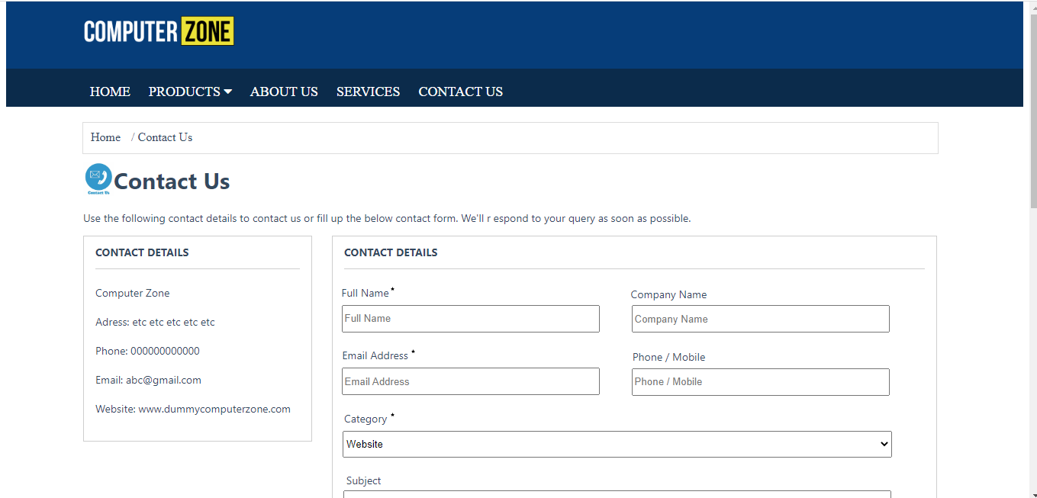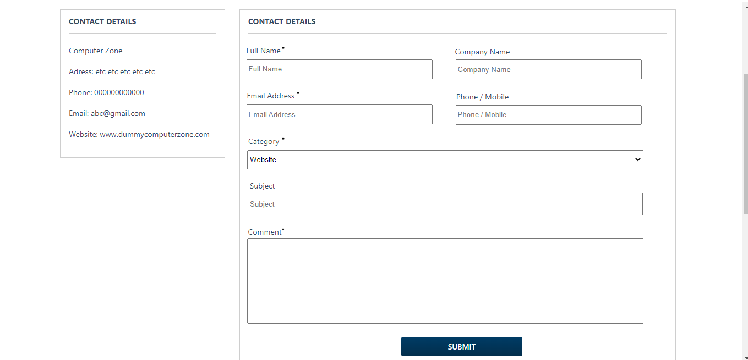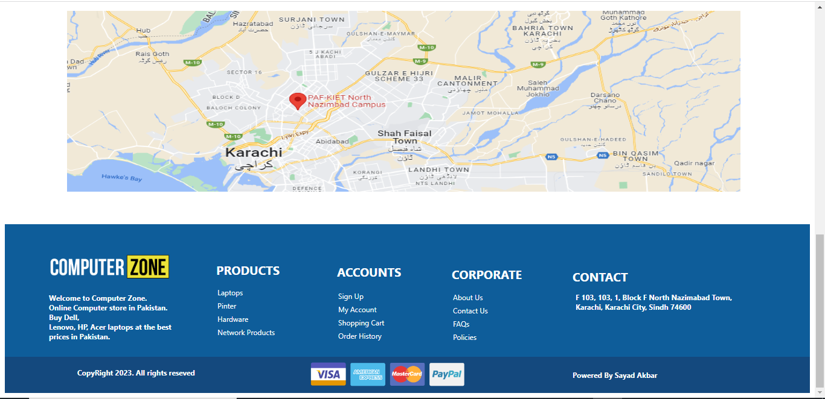

**Services Page Html::**

<!DOCTYPE html>

<html lang="en">

<head>

<link href="service.css" rel="stylesheet">

<link rel="stylesheet" href="https://cdnjs.cloudflare.com/ajax/libs/font-awesome/4.7.0/css/font-awesome.min.css">

<title>SERVICES</title>

</head>

<body>

<div class="logo">

<img src="2.png" style="margin-top: 20px; margin-left: 100px;" width="200px">

</div>

<div>

<nav>

<ul>

<li><a href="cz.html">HOME</a></li>

<li><a href="#">PRODUCTS

<i class="fa fa-caret-down" aria-hidden="true"></i>

</a>

<ul>

<li><a href="proudut.html">Laptop</a> </li>

<li><a href="proudut.html">Printer</a> </li>

<li><a href="proudut.html">Monitor</a> </li>

</ul>

</li>

<li><a href="about us.html">ABOUT US</a></li>

<li><a href="service.html">SERVICES</a></li>

<li><a href="contact us.html">CONTACT US</a></li>

</ul>

</nav>

</div>

<div class="br">

<ul3 class="ul3">

<li><a href="cz.html">Services</a> </li>

<li>/ About Us</li>

</ul3>

</div>

<h1 class="qqb">Frequently Asked Questions</h1>

<div class="cs">

<h1 class="xz">Payment/Delivery/Shipments</h1>

<div class="sc"></div>

<ol class="ol6">

<li>Can we place order online and what are payment options?</li>

<p>Of course, you can place orders online. Upon confirmation of your payment, we will dispatch your order as soon as possible. Total time is based on the amount of time it takes<br>

to get payment authorization, order processing, and the transit time from the carrier. This can range from 24 hours to 10 days for in-stock items. To avoid delays, please<br>

ensure that you have provided us with the correct Shipping address.</p>

<li>Is cash on delivery option available?</li>

<p>Yes Cash On Delivery is available for Karachi only.</p>

<li>Do the prices of On Order Products Change?</li>

<p>We do everything to ensure that the prices on our website are correct and try to keep prices constant. Sometimes we need to change the prices, either up or down without any<br>

prior notice due to change in Forex rates/government policies. Computer Zone reserves the right to change the prices on the website at any time without prior notice. In that<br>

case, if you have ordered the product but not yet confirmed or you have even paid for a product the prices would not be valid. It's better to confirm the price's of On Order<br>

Product's through phone call first and then deposit the amount after confirmation.</p>

</ol>

<div class="sc"></div>

<h1 class="qqa">Customer Reviews</h1>

<div class="sc"></div>

<ol class="ol6">

<li>Why do I write reviews?</li>

<p>

We want to hear your opinions. We want consumers to get the information they need to make smart buying choices. As a Czone client, you can submit reviews for items listed<br>

on czone.com.pk. We encourage you to share your ideas, both favourable and unfavourable.

</p>

<li>What are the Tips on writing a great review?</li>

<p>

<b>Include the "why":</b> The best reviews include not only whether you liked or disliked a product, but also why. Feel free to talk about related products and how this item<br>

compares to them.<br>

<b>Be specific:</b> Your review should focus on specific features of the product and your experience with it.<br>

<b>Not too short, not too long:</b> The ideal length is 75 to 500 words.<br>

<b>Be sincere:</b> We welcome your honest opinion about the product--positive or negative. We do not remove reviews because they are critical. We believe all helpful<br> information can inform our customers’ buying decisions.

</p>

<li>What's not allowed?</li>

<p>

Czone is pleased to provide this forum for you to share your opinions on products. While we appreciate your time and comments, we limit customer participation to one<br>

review per product and reserve the right to remove reviews that include any of the following: Objectionable material: • Obscene or distasteful content • Profanity or spiteful<br>

remarks • Promotion of illegal or immoral conduct Promotional content: • Advertisements, promotional material or repeated posts that make the same point excessively • <br>

Sentiments by or on behalf of a person or company with a financial interest in the product or a directly competing product (including reviews by publishers, manufacturers, or<br>

third-party merchants selling the product) • Reviews those are written for any form of compensation other than a free copy of the product. This includes reviews that are a part<br>

of a paid publicity package • Solicitations for helpful votes Inappropriate content: • Other people's material (this includes excessive quoting) • Phone numbers, postal mailing<br>

addresses, and URLs external to czone.com.pk • Comments on other reviews visible on the page (because page visibility is subject to change without notice)

</p>

</ol>

<div class="sc"></div>

<h1 class="qqa">Store Timing</h1>

<div class="sc"></div>

<ol class="ol6">

<li>What are your store hours?</li>

<p>

<b>Store Hours:</b><br>

Monday – Thursday: 11:00am to 8:00pm<br>

Friday: 11:00am to 1:00pm & 3:00pm to 8:00pm<br>

Sunday Closed.

</p>

</ol>

</div>

<footer class="fott">

<img src="2.png" width="200px" style="margin-left: 73px; margin-top: 50px;">

<h1 class="pa">Welcome to Computer Zone.<br> Online Computer store in Pakistan.<br>

Buy Dell,<br> Lenovo, HP, Acer laptops at the best<br> prices in Pakistan.</h1>

<h1 class="ba">PRODUCTS</h1>

<ul1 class="ul1">

<li><a href="proudut.html">Laptops</a><br></li>

<li><a href="proudut.html">Pinter</a><br></li>

<li><a href="#">Hardware</a><br></li>

<li><a href="#">Network Products</a><br></li>

</ul1>

</h1>

<h1 class="ta">ACCOUNTS</h1>

<ol>

<li><a href="#">Sign Up</a><br></li>

<li><a href="#">My Account</a><br></li>

<li><a href="#">Shopping Cart</a><br></li>

<li><a href="#">Order History </a><br></li>

</ol>

</h1>

<h1 class="a">CORPORATE</h1>

<ol1 class="ol1">

<li><a href="about us.html">About Us</a><br></li>

<li><a href="contact us.html">Contact US</a><br></li>

<li><a href="service.html">FAQs</a><br></li>

<li><a href="#">Policies </a><br></li>

</ol1>

</h1>

<h1 class="aa">CONTACT</h1>

<h1 class="bb">F 103, 103, 1, Block F North Nazimabad Town,<br> Karachi, Karachi City, Sindh 74600</h1>

</h1>

</footer>

<div class="fot">

<img src="20.png" width="270px" style="margin-left: 500px; margin-top: 5px;">

<h1 class="ee">CopyRight 2023. All rights reseved</h1>

<h1 class="w">Powered By Sayad Akbar</h1>

</div>

</body>

</html>

**Services page css::**

.logo{

width: 100%;

height: 90px;

background-color: #063d79;

margin-top: -10px;

}

nav {

background-color: #0b2b4b;

height: 50px;

}

nav ul {

padding: 0;

margin: 0;

list-style: none;

position: relative;

margin-left: 100px;

}

nav ul li {

display:inline-block;

}

nav a {

display:block;

padding:0 10px;

color:#FFF;

font-size:18px;

line-height: 60px;

text-decoration:none;

height: 50px;

}

nav a:hover {

background-color: rgba(0, 0, 0, 0.4);

color: #fff;

}

nav ul ul li {

width:170px;

float:none;

display:list-item;

position: relative;

margin-left: -100px;

background-color: #ffffff;

}

nav ul ul ul li {

position: relative;

top:-60px;

left:170px;

}

nav ul ul li a {

color: rgb(57, 47, 141);

box-shadow: 0 14px 28px rgba(0,0,0,0,0.25), 0 10px 10px rgba(0,0,0,0,0.22);

transition: .4s;

background: #f2f2f2;

}

nav ul ul {

display: none;

position: absolute;

}

nav ul li:hover > ul {

display:inherit;

}

.br{

width: 84%;

height: 40px;

border: 1px solid #ddd;

margin-top: 20px;

margin-left: 100px;

}

.ul3 li{

list-style-type: none;

display: inline-block;

margin-top: 10px;

margin-left: 10px;

color: #34495e;

}

.ul3 a{

text-decoration: none;

color: #34495e;

}

.qqb{

font-size: 26px;

font-family: system-ui, -apple-system, BlinkMacSystemFont, 'Segoe UI', Roboto, Oxygen, Ubuntu, Cantarell, 'Open Sans', 'Helvetica Neue', sans-serif;

color: #34495e;

margin-left: 100px;

}

.cs{

width: 84%;

height: 1270px;

border: 1px solid #ddd;

margin-top: 20px;

margin-left: 100px;

}

.xz{

font-size: 20px;

font-family: system-ui, -apple-system, BlinkMacSystemFont, 'Segoe UI', Roboto, Oxygen, Ubuntu, Cantarell, 'Open Sans', 'Helvetica Neue', sans-serif;

color: #34495e;

margin-left: 10px;

}

.sc{

margin: 0 15px;

padding: 7px 0 0 0;

text-align: center;

border-top: 1px solid #cecece;

}

.ol6 li{

font-size: 16px;

font-family: system-ui, -apple-system, BlinkMacSystemFont, 'Segoe UI', Roboto, Oxygen, Ubuntu, Cantarell, 'Open Sans', 'Helvetica Neue', sans-serif;

color: #34495e;

margin-left: 10px;

}

p{

font-size: 14px;

font-family: system-ui, -apple-system, BlinkMacSystemFont, 'Segoe UI', Roboto, Oxygen, Ubuntu, Cantarell, 'Open Sans', 'Helvetica Neue', sans-serif;

margin-left: 10px;

color: #34495e;

}

.qqa{

font-size: 26px;

font-family: system-ui, -apple-system, BlinkMacSystemFont, 'Segoe UI', Roboto, Oxygen, Ubuntu, Cantarell, 'Open Sans', 'Helvetica Neue', sans-serif;

color: #34495e;

margin-left: 10px;

}

.fott{

width: 100%;

height: 220px;

background-color: #0e5d9a;

margin-top: 50px;

}

.pa{

font-size: 12px;

color: #fff

}

.pa{

font-family: system-ui, -apple-system, BlinkMacSystemFont, 'Segoe UI', Roboto, Oxygen, Ubuntu, Cantarell, 'Open Sans', 'Helvetica Neue', sans-serif;

margin-left: 73px;

}

.ba{

font-size: 20px;

color: #ffffff;

margin-left: 350px;

margin-top: -140px;

}

.ul1 li{

list-style-type: none;

padding: 2px;

}

.ul1 a{

color: #ffffff;

text-decoration: none;

display: inline-block;

margin-left: 350px;

font-family: system-ui, -apple-system, BlinkMacSystemFont, 'Segoe UI', Roboto, Oxygen, Ubuntu, Cantarell, 'Open Sans', 'Helvetica Neue', sans-serif;

font-size: 12px;

}

.ul1 a:hover{

color: yellow;

}

.ta{

font-size: 20px;

color: #ffffff;

margin-left: 550px;

margin-top: -125px;

}

ol li{

list-style-type: none;

padding: 2px;

}

ol a{

color: #ffffff;

text-decoration: none;

display: inline-block;

margin-left: 510px;

font-family: system-ui, -apple-system, BlinkMacSystemFont, 'Segoe UI', Roboto, Oxygen, Ubuntu, Cantarell, 'Open Sans', 'Helvetica Neue', sans-serif;

font-size: 12px;

}

ol a:hover{

color: yellow;

}

.a{

font-size: 20px;

color: #ffffff;

margin-left: 740px;

margin-top: -143px;

}

.ol1 li{

list-style-type: none;

padding: 2px;

}

.ol1 a{

color: #ffffff;

text-decoration: none;

display: inline-block;

margin-left: 740px;

font-family: system-ui, -apple-system, BlinkMacSystemFont, 'Segoe UI', Roboto, Oxygen, Ubuntu, Cantarell, 'Open Sans', 'Helvetica Neue', sans-serif;

font-size: 12px;

}

.ol1 a:hover{

color: yellow;

}

.aa{

font-size: 20px;

color: #ffffff;

margin-left: 940px;

margin-top: -125px;

}

.bb{

font-size: 12px;

color: #ffffff;

margin-left: 945px;

margin-top: 10px;

}

.fot{

width: 100%;

height: 60px;

background-color: #14497e;

}

.ee{

font-family: system-ui, -apple-system, BlinkMacSystemFont, 'Segoe UI', Roboto, Oxygen, Ubuntu, Cantarell, 'Open Sans', 'Helvetica Neue', sans-serif;

font-size: 12px;

color: #ffffff;

margin-top: -40px;

margin-left: 120px;

}

.w{

font-family: system-ui, -apple-system, BlinkMacSystemFont, 'Segoe UI', Roboto, Oxygen, Ubuntu, Cantarell, 'Open Sans', 'Helvetica Neue', sans-serif;

font-size: 12px;

color: #ffffff;

margin-top: -20px;

margin-left: 940px;

}

**Service page output::**

